`

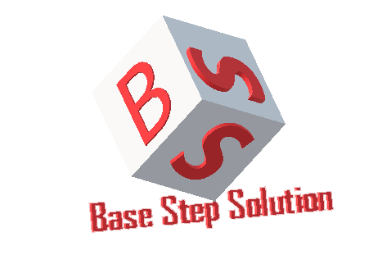

Meeting Minutes

Van Lang Admissions

# Revision Table

|  |  |  |  |
| --- | --- | --- | --- |
| **Author** | **Date** | **Reason for changes** | **Version** |
| Khoi Nguyen | 27/05/2017 | Initial Document | 1.0 |

Table of Contents

Revision Table 1

I. Purpose 3

II. participant in meeting 3

III. Content of meeting 3

1. Manage Account 3

2. Manage News 4

3. Manage examination 4

4. Manage Q&A 4

5. Manage banner 4

6. Manage language 4

IV. To do task 4

|  |  |  |  |  |  |
| --- | --- | --- | --- | --- | --- |
| **Writer:** | Khởi Nguyễn | **Location:** | Floor 7 , Campus 1 VLU | | |
| **Date:** | 27/05/2017 | **Start:** | 12h | **Finish:** | 12h30 |

# Purpose

Review All

# participant in meeting

Mentor Vũ Thế Nam

Team Capston:

* Nguyễn Thái Hiền
* Nguyễn Hoàng Anh Tài
* Đoàn Anh Minh
* Trần Xuân Hải
* Nguyễn Anh Khởi

# Content of meeting

* Cấu trúc thư mục nộp bài.
* Cách thức nộp tài liệu
* Fix all documents
* Complete collect documents
* Create Presentations ppt.

# To do task

* Complete collect documents.

---- *** ----